Andrew H. Rohn

SDEV 300 – Building Secure Web Applications

Section 2188

November 5th, 2018

Summary of Lab:

For this lab, I made a fake used car e-commerce website called “Andrew’s Budget Autos” that includes a brief description of the e-commerce website and displays a list of used cars in a table. The table includes the make and model of the car, a picture of the car, a description, the price, and a hyperlink for further information. Beneath the table there is a form where the user can select the car they would like to purchase and then fill out the necessary information to complete their order. There are also “submit” and “reset” buttons at the bottom of the page.

Here is a screen capture of me writing the HTML code for my website using the Virtual Machine on the SDEV AMI:

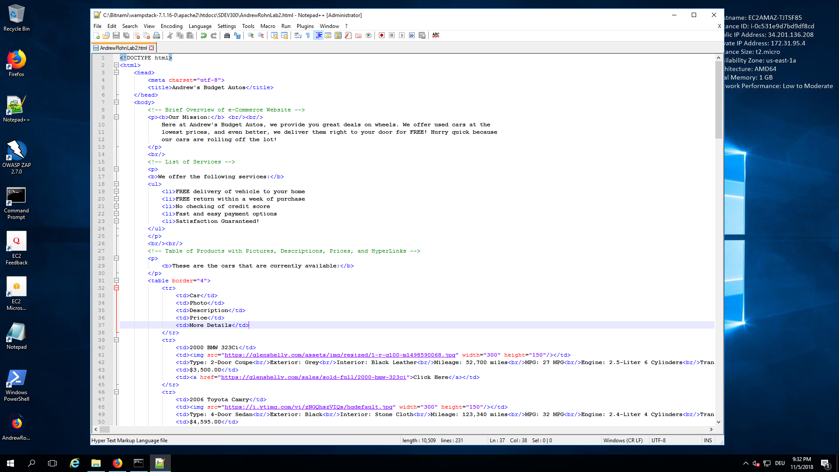

Here are some combined screen captures of my website:

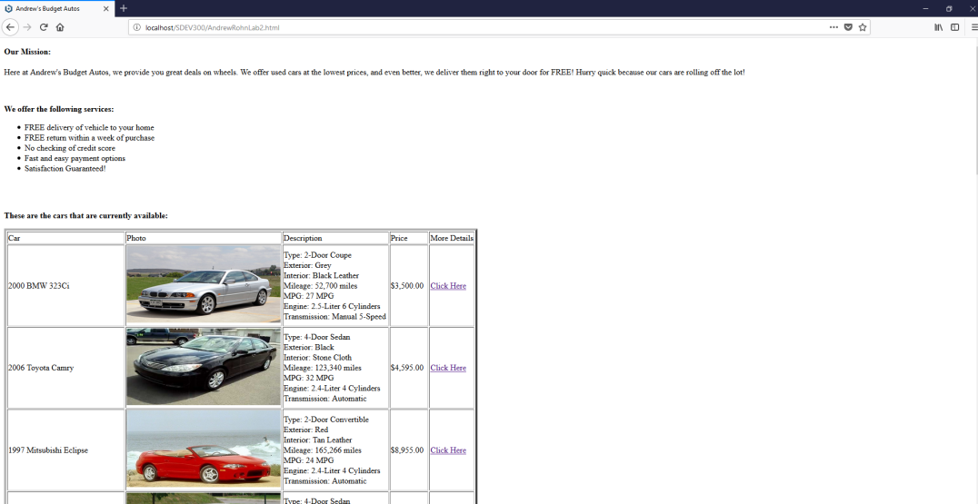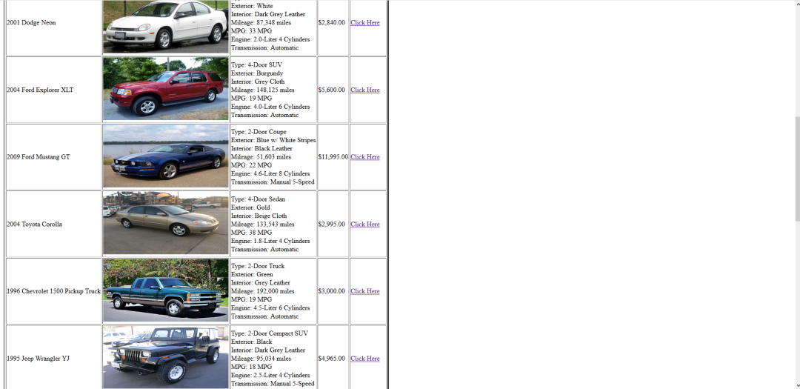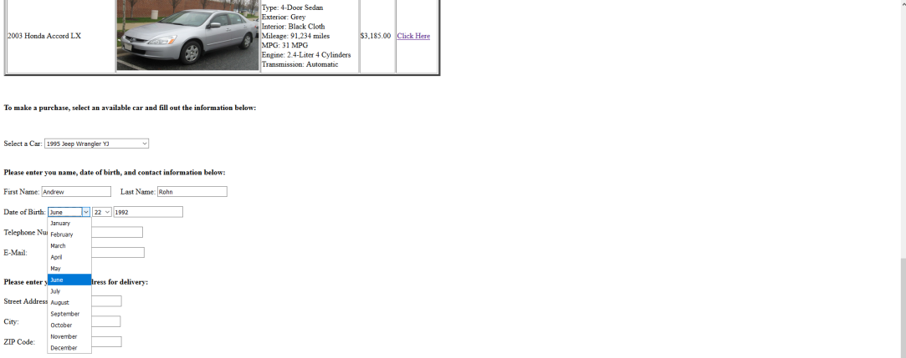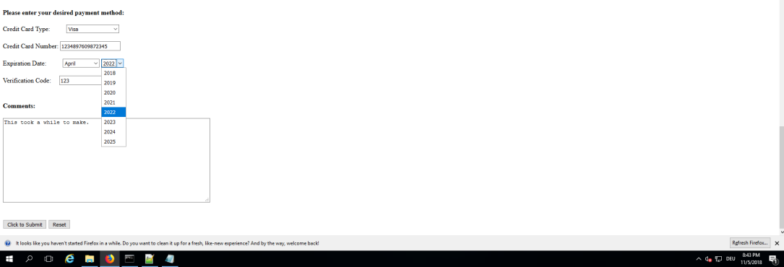

**Analysis of access.log**

HTTP Codes:

The HTTP Code that was consistently returned after each HTTP request verb “GET” was “200”. However, there were a couple of times where I manually entered the wrong URL and got the HTTP Code “404” because the page couldn’t be found as seen in these screen captures:

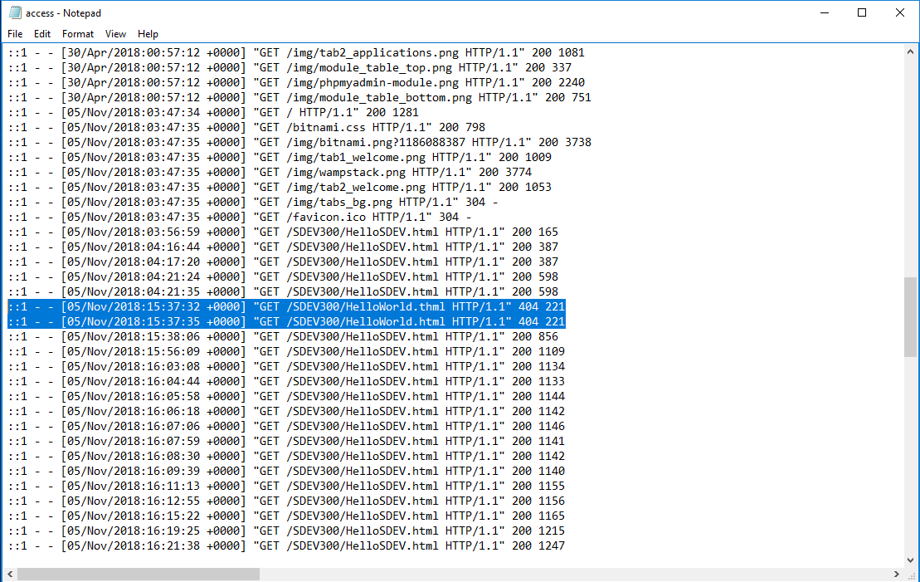

Screen capture of 404 Error:

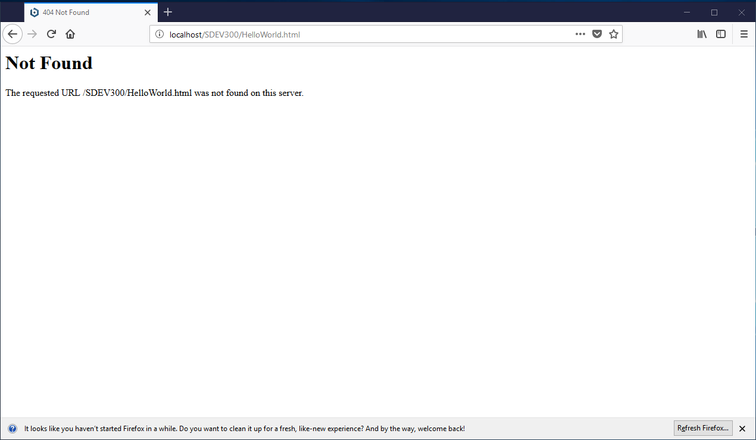

Request Methods:

Every time I tested my website, the “GET” request method was used. However, at the end when I chose to “submit” my order, the “POST” request method showed up. Here is a screen capture:

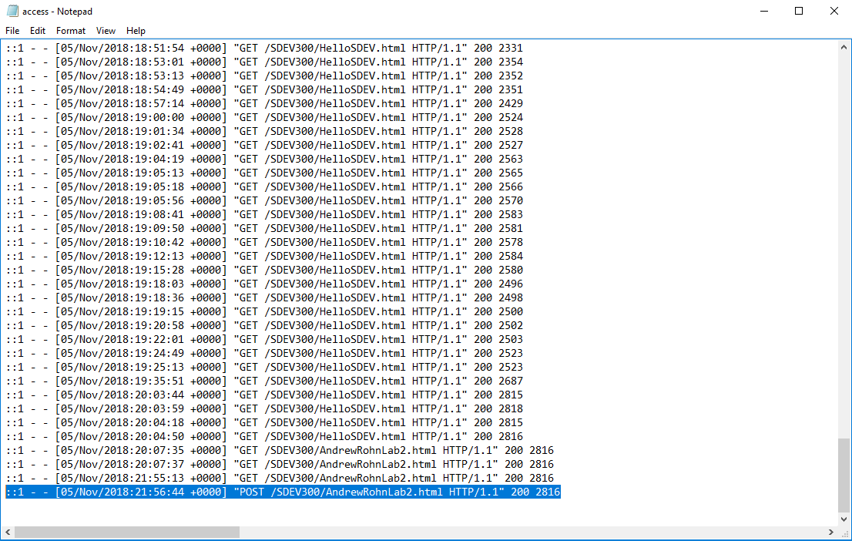

Timeline of Testing:

When I first began testing my website, the number of bytes returned with the “GET” request was a mere 165 Bytes, as shown here in this screen capture:

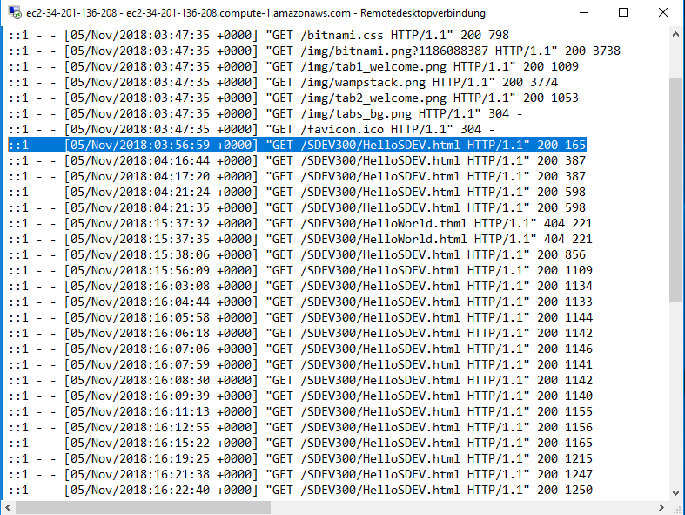

Shortly before finishing the website, I changed the name of the HTML file from “HelloSDEV.html” to “AndrewRohnLab2.html”. Once I finished making my website, the number of bytes returned had increased to 2816 Bytes, as shown in this screen capture:

